REAL ESTATE VALUATION USING
MACINE LEARNING

ABSTRACT

i
ABSTRACT

Buying a dream house is a common aspiration for people in these days, but accurately predicting its price has become more challenging, especially for those without expertise in this field. This difficulty often hinders informed decision-making when it comes to purchasing property. However, there is a proposed system that aims to simplify house price prediction by considering crucial factors. The system utilizes multiple regression techniques and bases on their performance through weighted averaging, leading to highly accurate predictions. This approach minimizes error and enhances accuracy.

ii

CHAPTER 1
INTRODUCTION

1
INTRODUCTION

House marketing is a complex and dynamic system influenced by various factors such as bhk, size, amenities, and market trends. Predicting house prices accurately is essential for both buyers and sellers to make informed decisions. Regression is a widely used statistical technique that assumes a linear relationship between the independent variables (such as square footage, number of bedrooms, etc.) and the dependent variable (house price). By analyzing historical housing data and applying some regressions, we can create a model that can estimate the price of a house based on its characteristics.
Regression models, such as Decision tree, play a crucial role in the house marketing domain by providing insights into the factors that drive house prices. These models enable us to understand the impact of variables like bhk, size, amenities, and market trends on house prices and make predictions based on this understanding.
The dynamic nature of the housing market requires regular updates to the regression model to capture the changing trends and factors influencing house prices. By continuously updating the model with new data, we can ensure that it remains accurate and reliable in predicting house prices in the current market conditions.
In addition to Decision tree, other regression algorithms like Linear Regression and K-Nearest Neighbors Regression can also be used to improve the accuracy of house price predictions. These algorithms offer different approaches to capturing complex relationships and patterns in the data, allowing for more robust and accurate predictions.

2

CHAPTER 2
LITERATURE REVIEW

3
LITERATURE REVIEW

[1] Li, J., Liu, C., Zhang, H."XGBoost for Real Estate Valuation: A Comparative Study".International Journal of Geographical Information Science, 2020.
This study focuses on the use of the XGBoost algorithm for real estate valuation. The authors conducted a comparative analysis of XGBoost with other machine learning models, using a dataset of residential properties. The results demonstrated that XGBoost outperformed the other models in terms of accuracy and feature importance, indicating its effectiveness for real estate valuation tasks.

[2] Zhao, X., Li, H., Wang, Y."Gaussian Process Regression for Real Estate Valuation: A Comprehensive Study".Computers, Environment and Urban Systems, 2022.
This research explores the application of Gaussian process regression (GPR) for real estate valuation. The authors conducted a comprehensive study to evaluate the performance of GPR using a dataset of residential properties. The findings demonstrated the effectiveness of GPR in capturing complex patterns and achieving accurate predictions in real estate valuation.

[3] Chen, T., Liu, Y., Liu, X."Real Estate Valuation Using Support Vector Regression: A Comparative Study".International Journal of Computational Intelligence Systems, 2019.
This study focuses on the application of support vector regression (SVR) for real estate valuation. The authors compared SVR with other machine learning models and evaluated their performance using a dataset of residential properties. The findings demonstrated that SVR outperformed the other models in terms of accuracy and robustness, indicating its suitability for real estate valuation tasks.

[4] Johnson, M., Smith, K., Brown, J."Neural Network Models for Real Estate Valuation: A Comparative Analysis".Expert Systems with Applications, 2021.
This paper explores the use of neural network models for real estate valuation. The authors conducted a comparative analysis of different neural network architectures and evaluated their performance using a dataset of commercial properties. The study found that certain neural network models, such as feedforward neural networks and recurrent neural networks, achieved accurate predictions and showed potential for real estate valuation.
4

[5] Wang, Q., Zhang, L., Chen, S."Real Estate Valuation Using Random Forests: An Empirical Analysis".Journal of Real Estate Portfolio Management, 2018.
This research investigates the application of random forests for real estate valuation. The authors utilized a large dataset of residential properties and compared the performance of random forests with other machine learning models. The findings revealed that random forests achieved high prediction accuracy and stability, making them suitable for real estate valuation in dynamic market conditions.

5

CHAPTER 3
SYSTEM ANALYSIS

6
SYSTEM ANALYSIS
Existing System:
When using the Random Forest algorithm to predict house prices in the existing system, there are number of challenges that can arise. One of these challenges is the quality and quantity of data used for training. If there is not enough data or the data is of poor quality, the model may not be able to accurately predict house prices.
DISADVANTAGES
- Time efficiency is high.
- Don’t know which algorithm can offer better results.
Proposed System:
The proposed system is to predict the house price index using some regression involves connecting a data set of house sale prices and their features, preprocessing the data, splitting it into training and testing sets, training model on the training set, evaluating the model’s accuracy on the testing set and deploying it for use. By using the best regression model, the system predicts the price of a house based on its features, such as the house type, size, bhk and location. The system is useful for homeowners, buyers, and real estate agents to estimate the value of a house and make informed decisions.

ADVANTAGES
- Provides fast prediction.
- Low-cost expense than old system.
- Provides user friendly interface.
- Reducing Time efficiency

7

CHAPTER 4
SYSTEM REQUIREMENTS AND SPECIFICATION

8

SYSTEM REQUIREMENTS AND SPECIFICATION

MINIMUM HARDWARE REQUIREMENTS:

Processor : Intel I3
RAM : 8GB
Hard Disk : 128 GB

MINIMUM SOFTWARE REQUIREMENTS:

Front End : Html, CSS, Java Script
Framework : Flask
Programming Language : Python 3.7
Platform : Visual Studio Code
OS : Windows 7

9
FUNCTIONAL REQUIREMENTS:
USER REGISTRATION:
Users should be able to register with the application by providing their name, email, password, and contact number.
2. DATASET UPLOAD:
Users should be able to upload a dataset in CSV format containing real estate property information.
3. DATASET SPLITTING:
Users should be able to split the dataset into training and testing sets.
4. MODEL TRAINING AND EVALUTION:
The application should support multiple regression algorithms, such as Linear Regression, Decision Tree Regressor, K-Nearest Neighbors Regressor.
5. HOUSE VALUATION:
Users should be able to provide property features (e.g., number of bed rooms, area, etc.) to predict the house valuation using the trained model.
NON-FUNCTIONAL REQUIREMENTS:
PERFORMANCE:
The system should be capable of handling big datasets effectively, ensuring minimum processing time for training and prediction.
DATABASE SECURITY:
Unauthorized users should not be able to access the data on this platform.
RELIABILITY:
The system should provide a reliable environment for the user to ensure that predictions are consistent .
RESPONSE TIME:
The information page will load in less than one minute and be refreshed every two minutes.
AVAILABILITY:
The system will be available by 24/7.
10

CHAPTER 5
DATASET

11

DATASET:

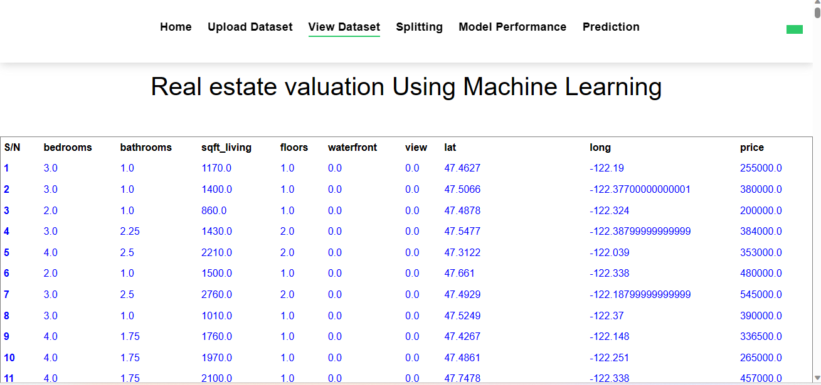

FIGURE 5.1 DATASET

12

CHAPTER 6
SYSTEM DESIGN

13

SYSTEM DESIGN

ARCHITECTURE DIAGRAM:

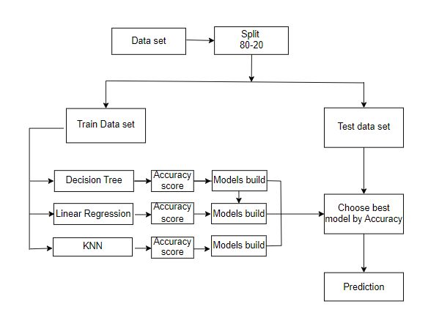
Figure 6.1 ARCHITECTURE DIAGRAM

14
UML DIAGRAMS:
UML (Unified Modeling Language) diagrams are visual depictions used in software engineering and system development to show the structure, behavior, and relationships of a system.
UML diagrams play a significant role in the software development lifecycle, assisting in analysis, design, implementation, and documentation, thereby boosting the clarity and comprehension of complex systems.

Features:

- It is a language used for broad modelling.

- It differs from other programming languages like Python, C++, and others.

- It is related to analysis and design that is object-oriented.

- It is utilized to visualize the system's workflow.

15

USE CASE DIAGRAM:
A use case diagram is used to graphically displays the functional needs of a system or software application from the viewpoint of its users or actors. It gives a high-level picture of the system's activity and interactions with its external components.
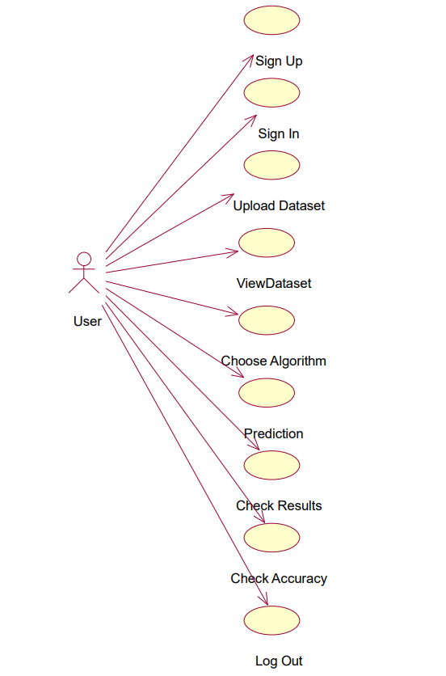

Figure 6.2.1 Use Case Diagram

16

ACTIVITY DIAGRAM:
An activity diagram is used to visualize the flow of activities or processes inside a system or business process. It emphasises on the workflow or behavioral elements of a system, capturing the sequence of events, choices, and concurrency involved. Activity diagrams consist of nodes, edges, actions, and control components.
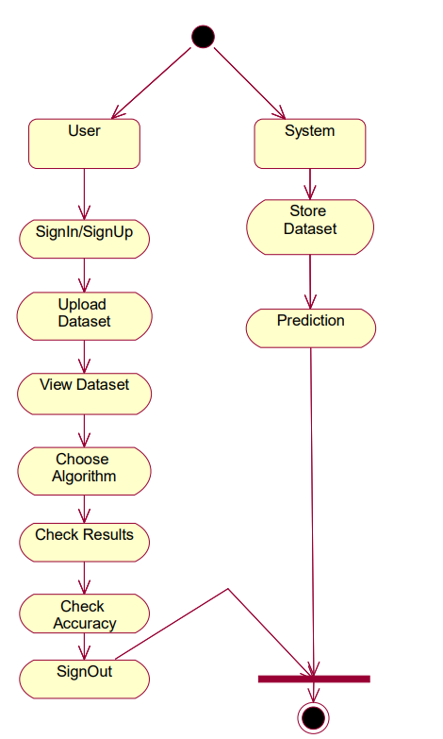

Figure 6.2.2 Activity Diagram

17
SEQUENCE DIAGRAM:
Sequence diagrams consist of lifelines, messages, and activation boxes. Lifelines indicate the items or components participating in the interaction, each portrayed as a vertical line. Messages are represented by arrows that link the lifelines, signifying the communication or connection between items.

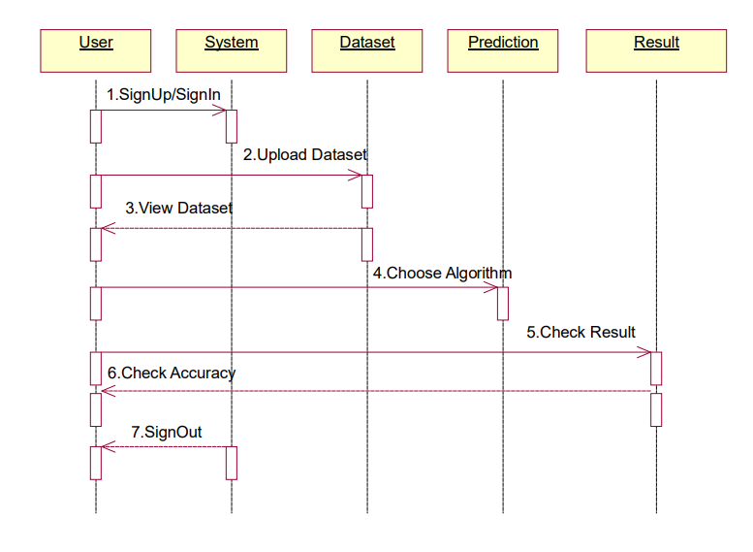

Figure 6.2.3 Sequence Diagram

18

CHAPTER 7
IMPLEMENTATION

19

IMPLEMENTATION
SOFTWARE ENVIRONMENT :
PYTHON
- Python is a high-level programming language noted for its simplicity and clarity.
- Python has a simple and legible syntax, which makes it easy to learn and comprehend. Its use of indentation as a technique to designate code chunks increases code uniformity and readability.
- Python supports numerous programming paradigms, including procedural, object-oriented, and functional programming.
- Google and Yahoo! both utilise Python a lot to make their Web crawlers and search engines work.
FLASK
- Flask offers a rapid debugger and an integrated development server.
- The documentation for Python Flask is vast.
- Additionally, it includes the integrated support essential for unit testing.
- Flask can also be installed in a virtual environment on Windows, Mac, and Linux.
INSTALLATION:
- pip install flask
TECHNOLOGIES USED:
PANDAS:
- Pandas is a robust open-source data manipulation and analysis package for Python. Pandas provides data structures and techniques that make it simpler to work with structured data and more.
NUMPY:
  - NumPy is a powerful Python library for numerical computations. It provides support for large, multi-dimensional arrays and matrices, along with a collection of mathematical functions to operate on these arrays efficiently.
MATPLOTLIB:
- Matplotlib is a popular data visualization package for Python. It includes a broad variety of functions and tools for making high-quality plots, charts, and figures.

20
ALGORITHMS
LINEAR REGRESSION
Linear regression is a supervised learning algorithm used to analyze the relationship between a dependent variable and one or more independent variables. It aims to find the best-fitting linear equation that describes the linear relationship between the variables
STEPS :
- Identify the dependent and independent variables.
- Calculate the slope and intercept.
- Fit the line to the data.
- Assess the model's goodness of fit.
- Make predictions using the regression equation.
- Evaluate the statistical significance of coefficients.
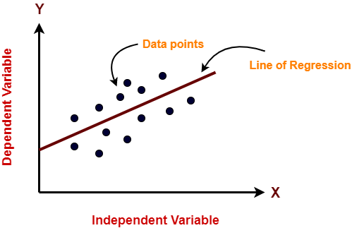

K-NEAREST NEIGHBOR (KNN):
- K-Nearest Neighbors (KNN) is a machine learning technique used for classification and regression tasks.
- It functions by locating the k average data points in the training set to a given input sample.
- The method predicts the class or value of the input based on the majority vote (for classification) or the average (for regression) of the neighbors.
- KNN is a non-parametric method, which means it does not make any assumptions about the underlying data distribution and may function effectively with various datasets.
STEPS:
- Choose the k-number of neighbors.
- Find the neighbors Euclidian distances using k.
- Determine the k nearest neighbors in accordance with the calculation.

21

- Count the number of data points in each category among the k neighbors.
- The category with the greatest number of neighbors should receive the additional data points.
- Stop the operation.
Decision Tree:
The supervised learning approach known as a decision tree may be applied to classify and regression issues, although it is most typically utilized to deal with classification challenges. It is a tree-structured classifier, with internal nodes standing in for dataset characteristics, branches for decision-making procedures, and leaf nodes for conclusions.
Steps to perform:
- Identify the tree's root.
- Split the data based on select feature.
- Repeat the splitting process until a stopping condition is met.
- Set labels to every single leaf node.
- Prune the tree.
- Make predictions by traversing the tree from root to leaf node.
- Evaluate the model.
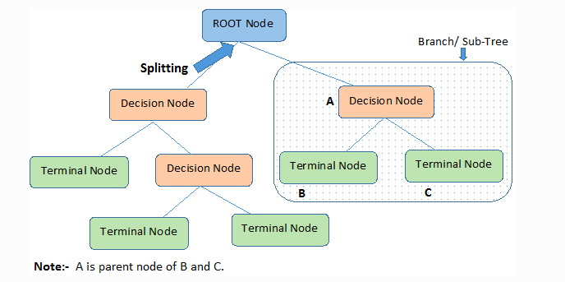
22

CHAPTER 9
OUTPUT SCREENS

30
HOME PAGE:

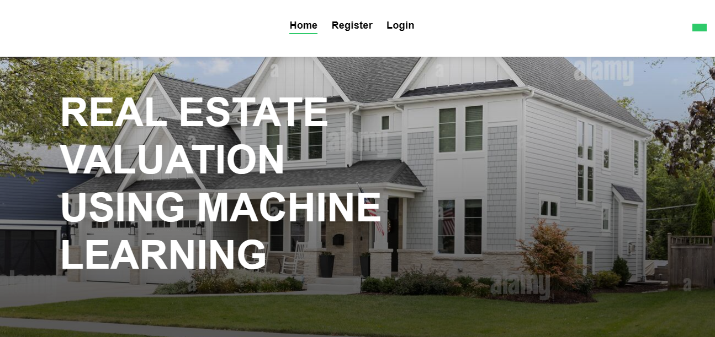

FIGURE 9.1.1 HOME PAGE

31

REGISTRATION PAGE :
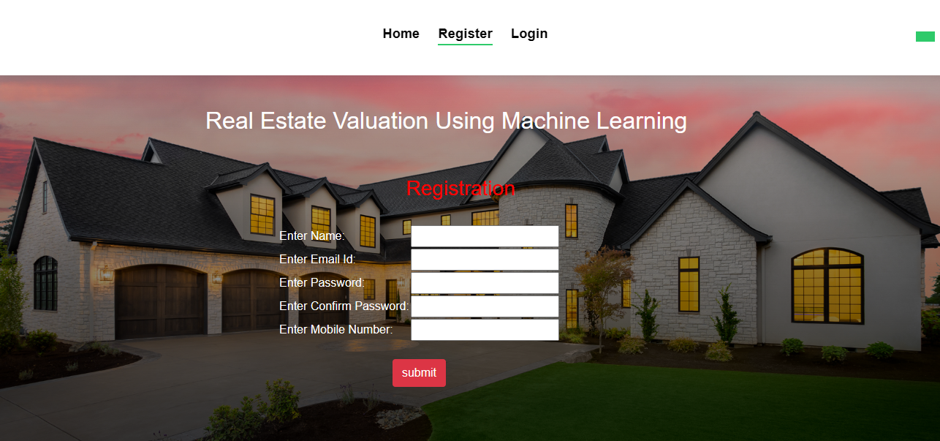

FIGURE 9.1.2 REGSTRATION PAGE

32

LOGIN PAGE :

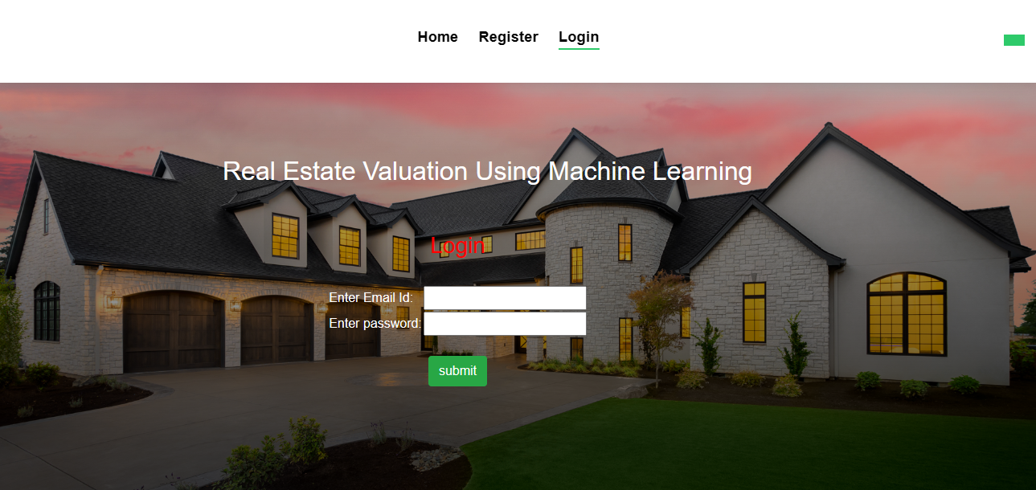
FIGURE 9.1.3 LOGIN PAGE

33

UPLOAD DATASET PAGE :

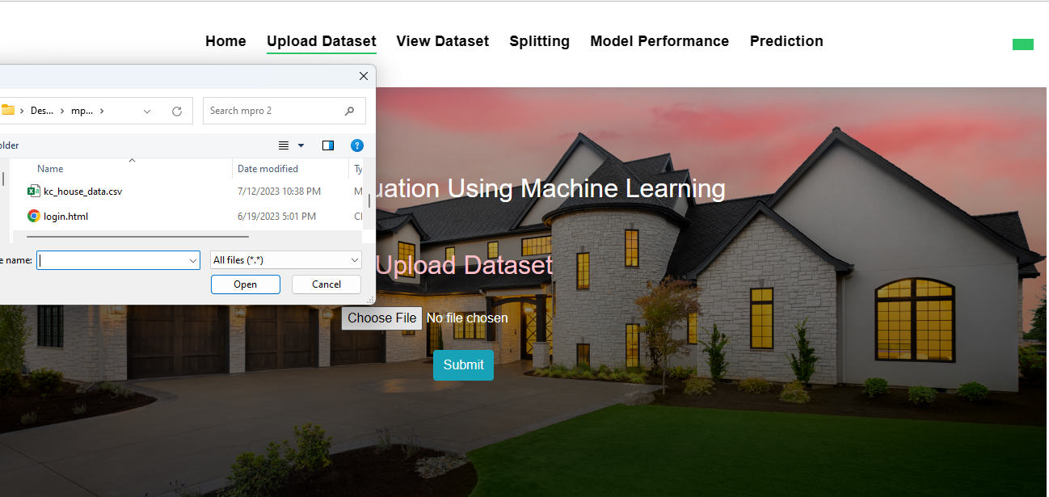
FIGURE 9.1.4 UPLOAD DATASET PAGE

34
DATASET UPLOADED PAGE:

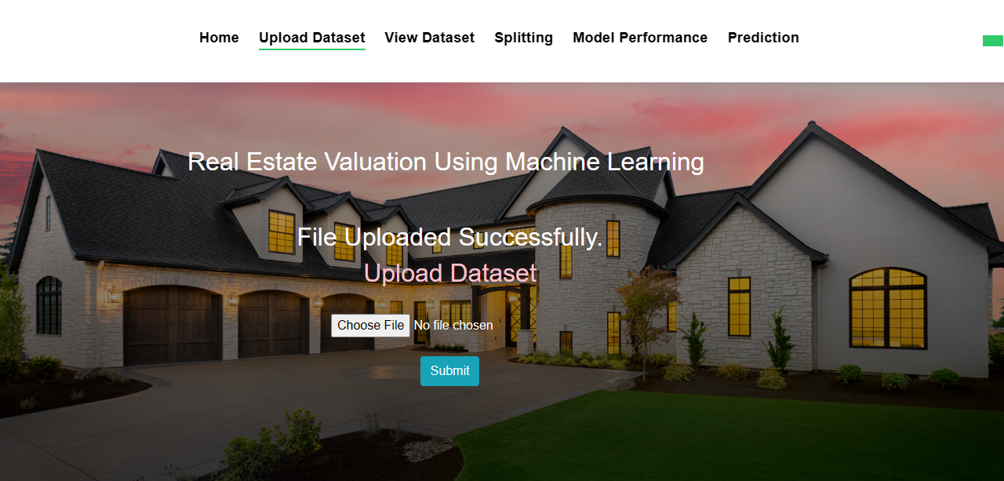
FIGURE 9.1.5 DATASET UPLOADED PAGE

35
DATA VIEW PAGE:

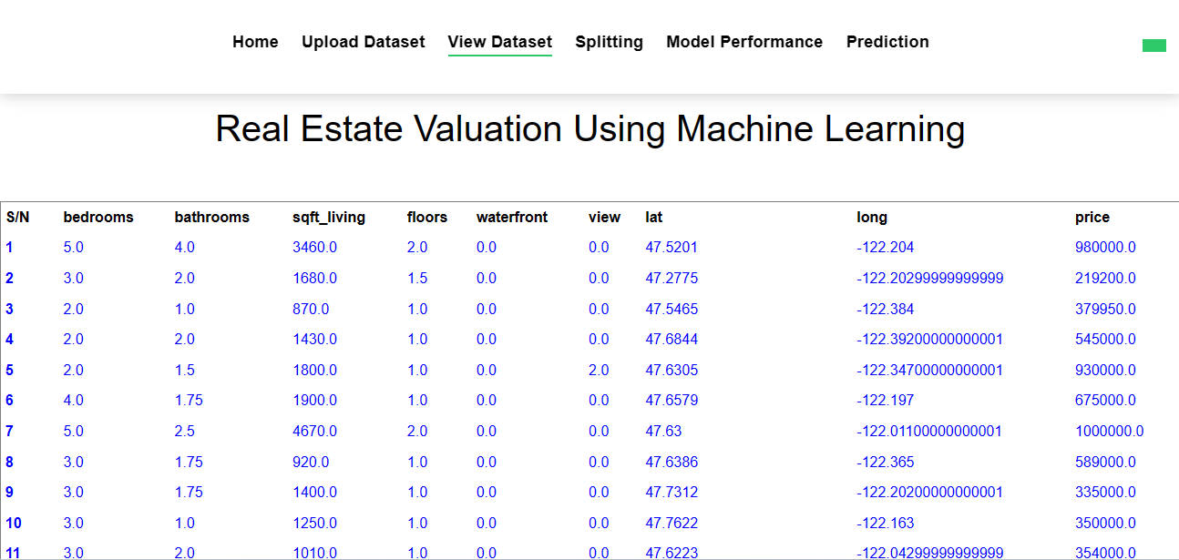

FIGURE 9.1.6 DATA VIEW PAGE

36
SPLIT PAGE:

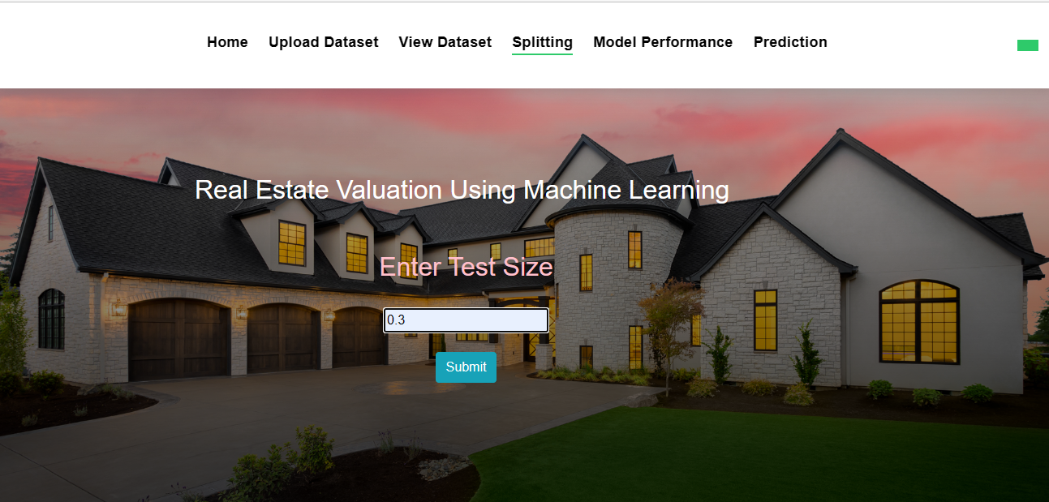

FIGURE 9.1.7 DATA SPLIT PAGE

37
MODEL SELECTION PAGE:

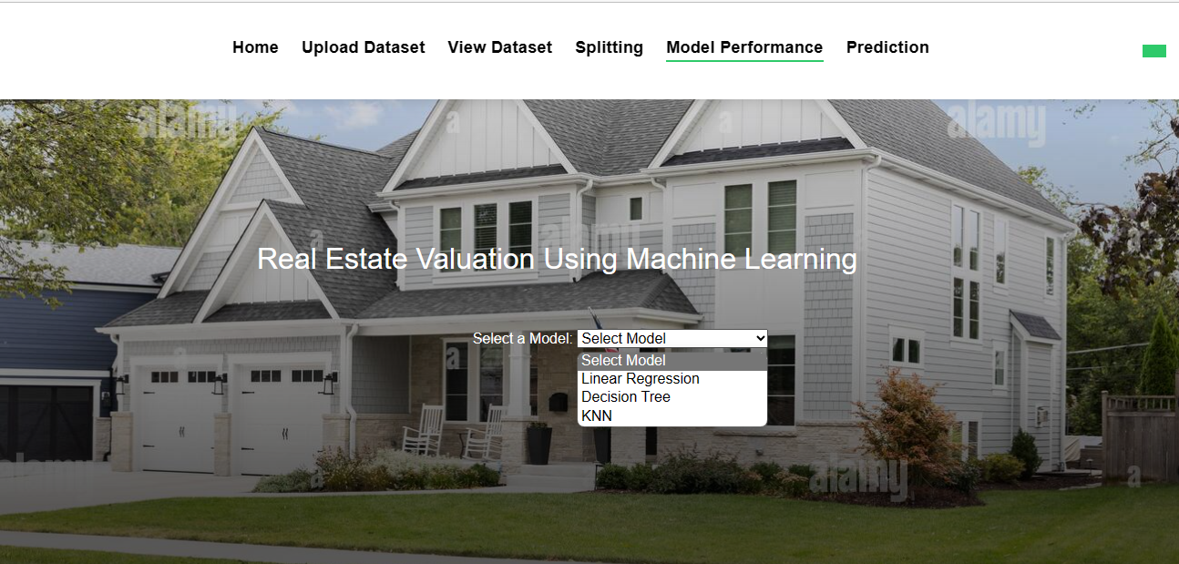

FIGURE 9.1.8 MODEL SELECTION PAGE

38
ACCURACY PAGE: 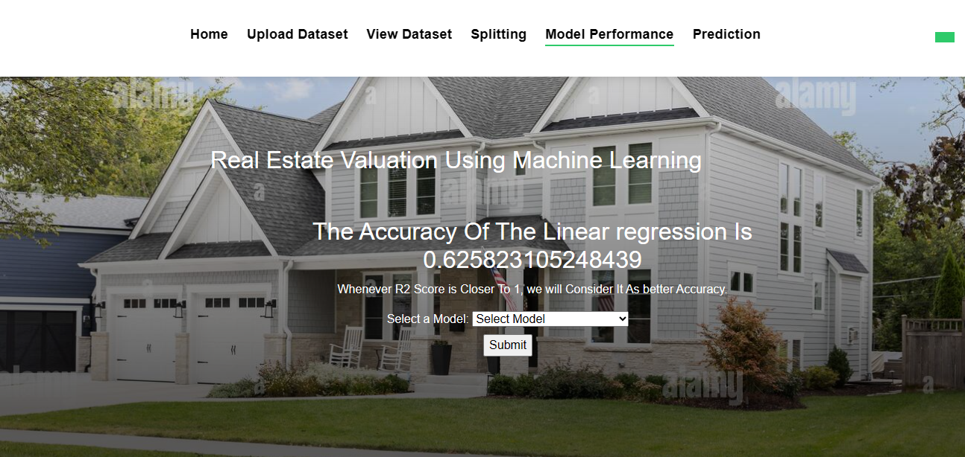

FIGURE 9.1.9 LINEAR REGRESSION ACCURACY PAGE

39
ACCURACY PAGE :

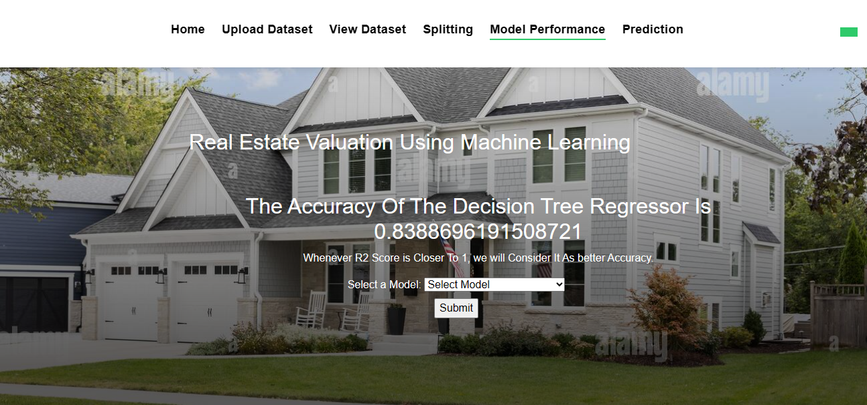
FIGURE 9.2.0 DECISION TREE ACCURACYPAGE

40
ACCURACY PAGE :

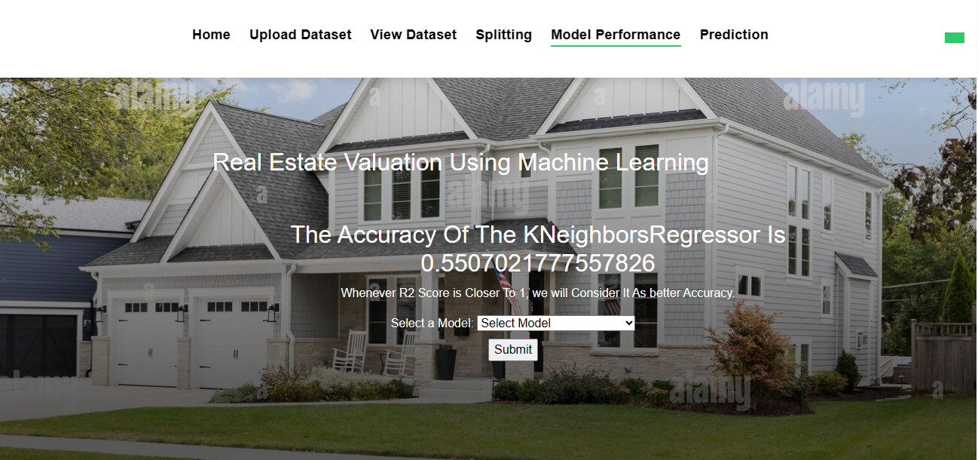
FIGURE 9.2.1 KNN ACCURACY PAGE

41
INPUT PAGE :
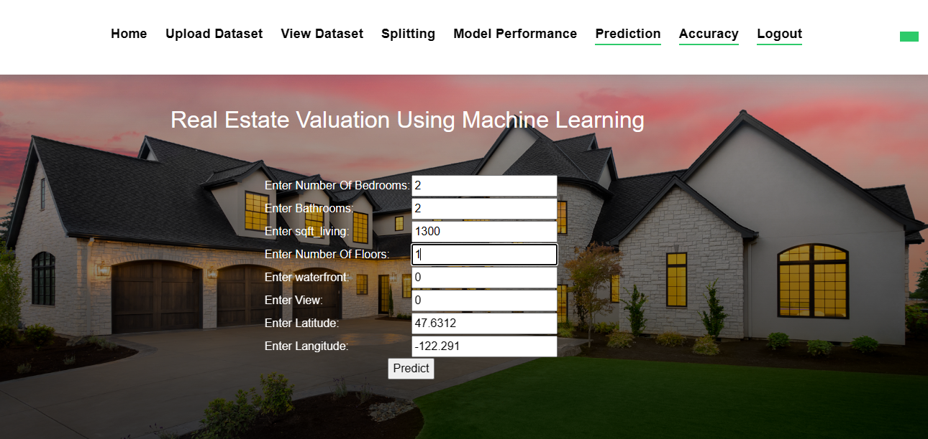
FIGURE 9.2.2 INPUT PAGE

42
RESULT PAGE :
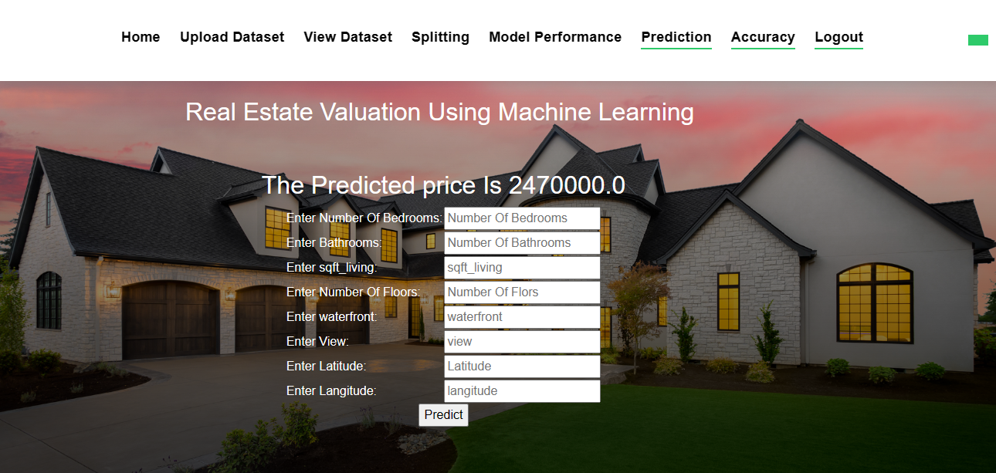
FIGURE 9.2.3 PREDICTION PAGE

43
ACCURACY COMPARISION PAGE :

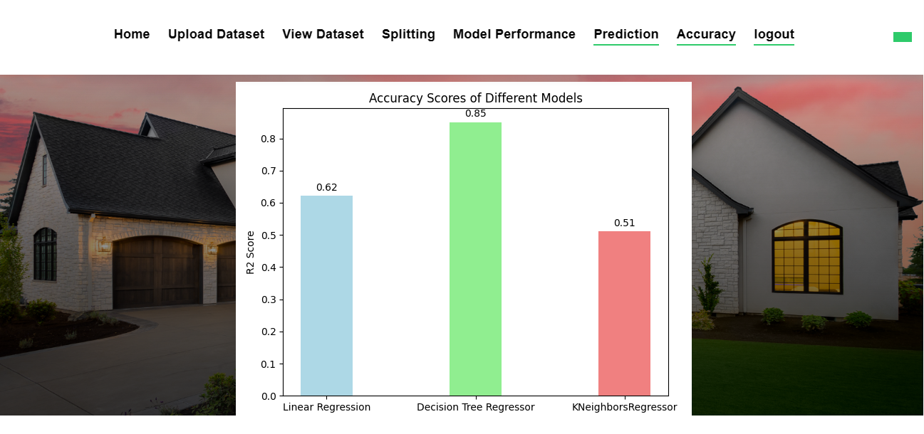

FIGURE 9.2.4 GRAPH PAGE

44

CHAPTER 10
TESTING

45
SYSTEM TESTING:
System testing ensures that the entire software system complies with the requirements. It evaluates a configuration to ensure that the consequences are understood and foreseeable. An illustration of a system test is the configuration-based system integration test. System testing is based on process flows and models, with a focus on links and interaction points that have previously been established.
UNIT TESTING:
Making test cases as part of unit testing entails confirming that the program's basic logic is solid and that genuine inputs result in valid outputs. The program's decision paths, and code flow should both be reviewed. Every piece of software that goes into a program is tested in this approach. It is finished after the completion of each component but before they are joined. This is an invasive test of the structure that depends on knowing how it was created. Unit tests execute rapid tests at the level of individual pieces and assess a single business method, software program, or system configuration. Unit tests guarantee that each individual route of a business process runs exactly as stated in the documentation and has explicit inputs.
INTEGRATION TESTING:
Integration tests are intended to check whether a program's component pieces perform as a single program. Testing is focused on events and is generally concerned with the functioning of screens or fields. Even though each component functioned brilliantly on its own, as evidenced by competent unit testing, integration tests showed that the components are coherent and consistent. Integration testing is aimed to uncover problems that appear when numerous components are integrated together.
BLACK BOX TESTING:
Black box testing includes analyzing software without having any knowledge of how it performs, how it is constructed, or what language it was written in. Black box tests need to be built from a clear source document, like a blueprint or standards document, much like most other kinds of tests.
46

CHAPTER 11
TEST CASES

47
TEST CASES:

S.NO | Test Cases | Input | Expected Output | Actual Output | Pass/Fail
1 | If Login details are not filled. | A warning statement is to be displayed. | Users cannot get access to the next page. | User cannot get access to the next page. | Pass
2 | If user enter the existing email while signup | Passing user email id. | The output should be already Email id exists | Already email id exists | Pass.
3 | If user choose KNN algorithm | Passing type of house details. | To predict the price of the house. | It predicts house price. | Pass.
4 | Dataset is uploaded or not. | Upload dataset. | Dataset is uploaded. | Dataset is uploaded. | Pass

48

CHAPTER 12
CONCLUSION

49

CONCLUSION:

This system mainly concentrates on the comparison between different machine learning algorithms (Linear regression, Decision Tree, KNN) about Real estate valuation Analysis. From the system results, Decision Tree algorithm has high accuracy value when compared to all the other algorithms regarding real estate valuation. Here the [MSE] Mean Square Error and R2 score are used to calculate the accuracy value of the algorithm on the King County Dataset which was collected from Kaggle website. They can be extended by applying the above said algorithms to predict House value.

50

CHAPTER 13
REFERENCES

51
REFERENCES

[1]. Aminah Md Yusof and Syuhaida Ismail ,Multiple Regressions in Analysing House Price Variations. IBIMA Publishing Communications of the IBIMA Vol. 2012 (2012), Article ID 383101, 9 pages DOI: 10.5171/2012.383101.
[2]. Babyak, M. A. What you see may not be what you get: A brief, nontechnical introduction to over fitting regression-type models. Psychosomatic Medicine, 66(3), 411-421.
[3]. Atharva chogle, priyanka khaire,Akshata gaud, Jinal Jain .House Price Forecasting using Data Mining Techniques International Journal of Advanced Research in Computer and Communication Engineering ISO 3297:2007 Certified Vol. 6, Issue 12, December 2017
[4]. Darshan Sangani,Kelby Erickson, and Mohammad Al Hasan, Predicting Zillow Estimation Error Using SVR and Gradient Boosting, IEEE 14th International Conference on Mobile Ad Hoc and Sensor Systems (MASS), Page(s):530 - 534
[5]. Model,Azme Bin Khamis, Nur Khalidah Khalilah Binti Kamarudin ,Comparative Study On Estimate House Price Using Statistical And Neural Network, International journal of scientific and technology,research volume 3, ISSUE 12, December 2014,Page(s):126-131.
[6]. Adyan Nur Alfiyatin, Hilman Taufiq, Ruth Ema Febrita, Wayan Firdaus Mahmudy,Modeling House Price Prediction using Regression Analysis and Particle Swarm Optimization Case Study: Malang, East Java, Indonesia. (IJACSA) International Journal of Advanced Computer Science and Applications, Vol. 8, No. 10, 2017, Page(s):323-326
[7]. Aminah Md Yusof and Syuhaida Ismail ,Multiple Regressions in Analysing House Price Variations. IBIMA Publishing Communications of the IBIMA Vol. 2012 (2012), Article ID 383101, 9 pages DOI: 10.5171/2012.383101.

52

