DATASET DESCRIPTION

Dataset Name : kc_house_data - (King Country)
Website : Imported from Kaggle.com
Size : 21614 rows(observations) * 21 columns (attributes)
Total Column Names: id, date, bedrooms, bathrooms, sqft_living, sqft_lot, floors, waterfront, view, condition, grade, sqft_above, sqft_basement, yr_built, yr_renovated, zipcode, lat, long, sqft_living15, sqft_lot15, price.
Used Columns :bedrooms, bathrooms, sqft_living, floors, waterfront, view, lat, long, price.
Class Label : price.
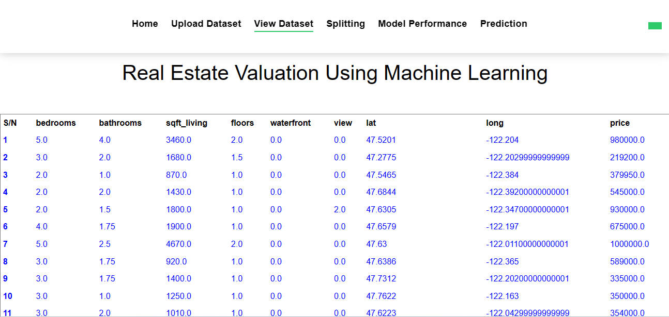
Description For the Used Columns

- S/N : It indicates the serial number of the house data.

- Bedrooms : It indicates the number of bedrooms.

- Bathrooms : It indicates the number of bathrooms.

- Sqft_living : It indicates the sqft of the house.

- Floors : It indicates the number of floors in house.

- Waterfront : It indicates the water source in front of the house.

- View : It indicates the house rating.

- Lat : It indicates the house latitude.

- Long : It indicates the house longitude.

- Price : It indicates the price of a house.

What does 2.5 bathrooms mean?
Bathrooms = 1, 1.25, 1.5, 1.75.
- In the US it means there are two “full” bathrooms and one “half” bathroom.
- A full bathroom has a sink, toilet, and either a tub/shower combo or separate tub and shower.
- A three-quarters bath has sink, toilet, and either a tub OR a shower, but not both.
- A half-bath has a sink and a toilet - no tub or shower. These are often called “powder rooms” since a lady would often say “I need to powder my nose” instead of “I need to pee”.
- A quarter-bath has only a toilet. These are uncommon now, but usually found in garages or workshops so Dad didn’t have to come back into the house all dirty/greasy just to use the bathroom.

What does 1, 1.5 Floors ?
- One and a half story home plans place all main living areas and usually also the master suite on the first floor. Additional rooms and/or loft space for children, visitors, and flex use are placed upstairs to help provide more square footage without expanding the size of the home's footprint.

